Links we need to look at

http://tilwykes.com/

https://wearemhabitat.com/about-us/meet-the-team/victoria-betton

https://sydney.edu.au/research/opportunities/opportunities/1244

https://sydney.edu.au/research/opportunities/opportunities/1368

https://sydney.edu.au/research/opportunities/opportunities/1545

https://sydney.edu.au/research/opportunities/opportunities/1825

Books

1-Teen Mental Health in an Online World: Supporting Young People around their Use of Social Media, Apps, Gaming, Texting and the Rest Paperback – 18 Oct 2018

by Victoria Betton and James Woollard (Author)

2- The Oxford Handbook of Affective Computing

Edited by Rafael A. Calvo, Edited by Sidney D'Mello, Edited by Jonathan Gratch, and Edited by Arvid Kappas Published: 15 January

3- Positive computing: technology for wellbeing and human potential

RA Calvo, D Peters – 2014.

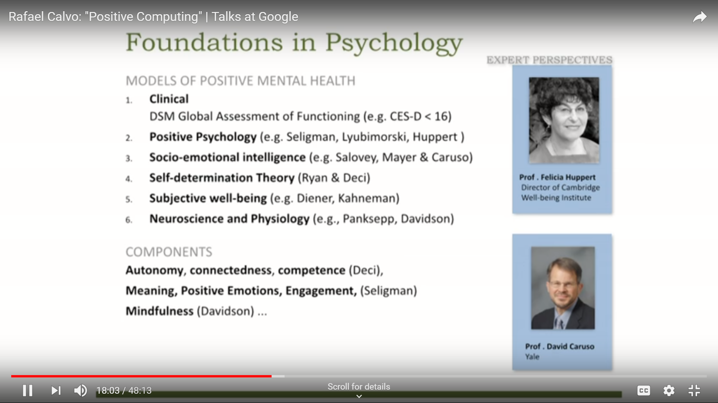

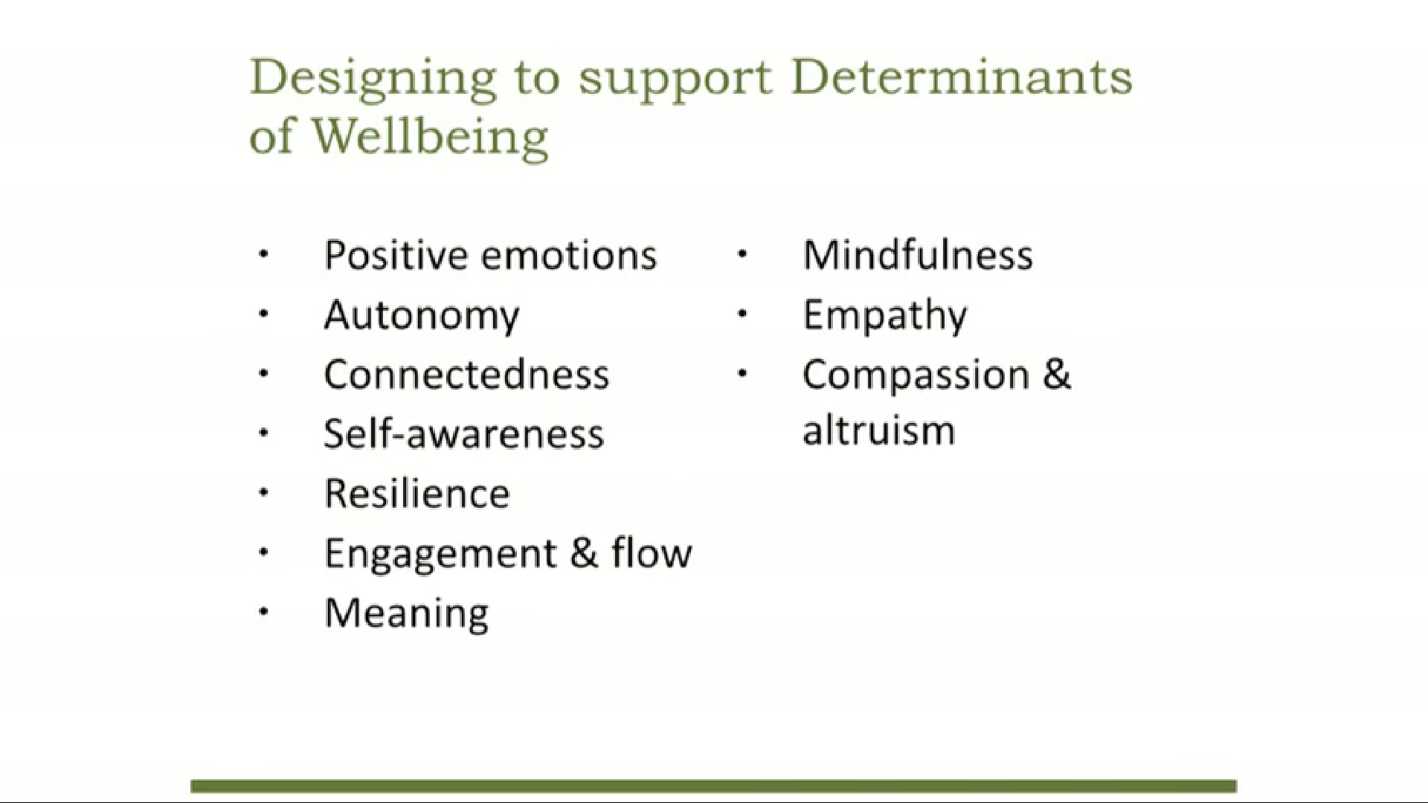

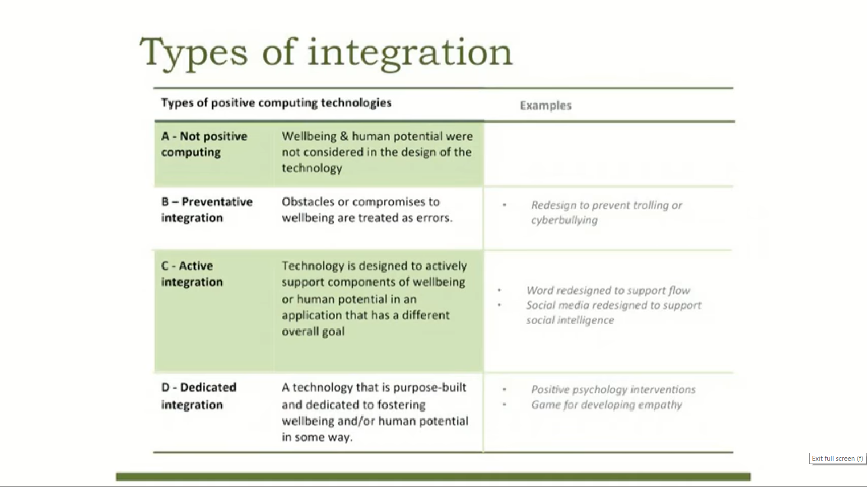

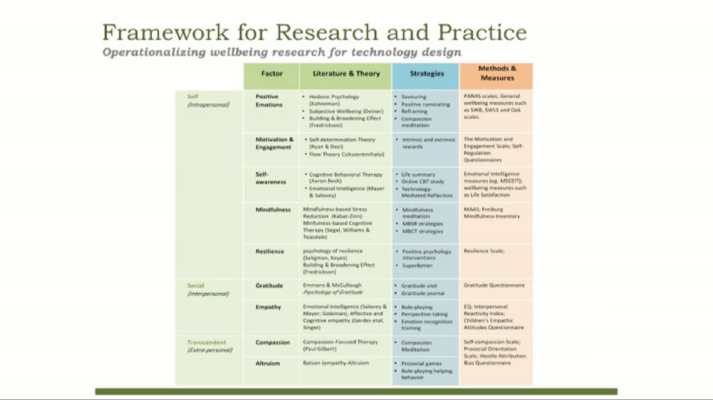

Need access to this

1-Computing in Mental Health

Rafael A. Calvo, Karthik Dinakar, Rosalind Picard, Pattie Maes

https://dl.acm.org/citation.cfm?id=2856463

2-Introduction to Positive Computing: Technology that Fosters Wellbeing

Rafael A. Calvo The University of Sydney, Sydney, NSW, Australia

Dorian Peters

https://dl.acm.org/citation.cfm?id=2706674

3-Social media can help in recovery – but are mental health practitioners up to speed?

Victoria Betton (Deputy Director of Partnerships and Innovation, based at Leeds and York Partnership NHS Foundation Trust, Strategy and Partnerships Department, Leeds, UK)

Victoria Tomlinson (Chief Executive, based at Northern Lights PR, Harrogate, UK)

<https://www.emeraldinsight.com/doi/pdfplus/10.1108/MHSI-06-2013-0021>

To order from library

https://www.kcl.ac.uk/library/using/requests/interlending/index.aspx

New studies

1-Natural language processing in mental health applications using non-clinical texts.

2- Insights from a Workshop on Social Media Analysis and Mental Health: Putting People at the Centre of Human Data.

3- The role of social media in reducing stigma and discrimination.

4- A multi-componential analysis of emotions during complex learning with an intelligent multi-agent system.

5- Designing a Secure Architecture for m-Health Applications.

6- Development and validation of a prediction algorithm for the onset of common mental disorders in a working population.

7- Promoting Psychological Wellbeing: Loftier Goals for New Technologies.

8- When Technologies Manipulate Our Emotions.

9- Using different Facebook advertisements to recruit men for an online mental health study: Engagement and selection bias.

# 10- Worker Preferences for a Mental Health App Within Male-Dominated Industries: Participatory Study

<https://www.ncbi.nlm.nih.gov/pmc/articles/PMC5943624/>

<https://www.youtube.com/watch?time_continue=12&v=viKJ1PrImeM>

# 11- Toward Impactful Collaborations on Computing and Mental Health.

# <https://www.ncbi.nlm.nih.gov/pmc/articles/PMC5889813/>

Cyberpsychology (also known as Internet psychology or web psychology) is a developing field that encompasses allpsychological phenomena associated with or affected by emerging technology.